Paper Title (Title Case, 18 Bold)
First Author1*, Second Author and Further Author List 2 ¹Department, College/University Name, Country Name ²Department, College/University Name, Country Name

Abstract
The abstract very concisely describes the contents of your paper. It states simply what work you undertook, your results and your conclusions. Importantly, like the title, the abstract will help potential readers to decide whether your full paper will be of interest to them. Try to keep the abstract below 250 words. Do not make references nor display equations in the abstract. The manuscript should be printed on A4 paper. It is imperative that the margins and style described below be adhered to carefully. This will enable us to keep uniformity in the final printed copies of the Journal. Please keep in mind that the manuscript you prepare will be photographed and printed as it is received. Readability of copy is of paramount importance.

Keywords: About five key words separated by comma

*Author for Correspondence E-mail: mailid@author, Tel:

INTRODUCTION
The introduction clearly states the object of your work, its scope and the main advances you are reporting. It gives reference to relevant results of previously published work. A theoretical and experimental methods section gives sufficient information about the research carried out by the researcher. The results and discussion section states your results and their potential implications. In the discussion you should state the impact of your results compared with recent work.

The references in the paper should be cited according to the Vancouver/Numbered style. Reference citation should be always in square brackets and before the punctuation [1]. The references should be arranged in proper numeral [2] sequence.

SECTION MAIN HEADINGS

Subheadings
The main headings or the first level headings should be written in all caps (Times New Roman, Bold, Font size 12).
The subheadings or the second level headings should be written in Title case (Times New Roman, Bold, Font size 11).
Further Subsequent Headings: should me made run on with the text separated by a column.

FIGURES AND TABLES
Carefully chosen and well prepared figures, such as diagrams and photos, can greatly enhance the quality of the paper. We encourage you to prepare figures that are clear, easy to read, and of the best possible quality.

Figure captions should appear below the figure in Title case (first letter of each word capital). When referring to a figure in the body of the text, the abbreviation "Fig." should be used. Figures should be numbered in the order they appear in the text. Table captions appear centered above the table in Title case. When referring to a table in the text, no abbreviation is used and "Table".

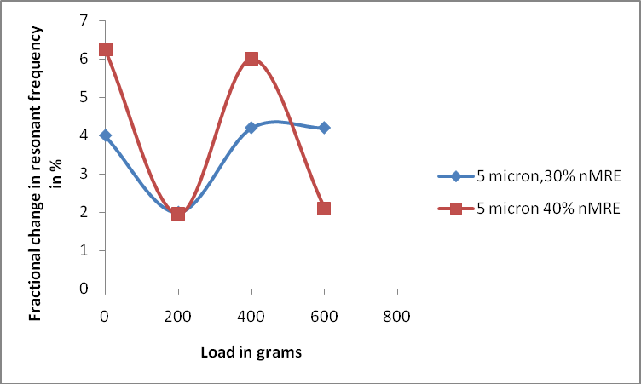

Fig. 1: Figure Caption in Title Case.
(Note: The image used should be clear and of high resolution.)

Table 1: Table Caption in Title Case.
Column Head | Bold | Column Head
1 | 200 | fa
2 | 200 | fb
3 | 200 | fc
4 | 200 | fd

CONCLUSIONS
Conclusions summarize key results and may include any plans for relevant future work.

ACKNOWLEDGMENTS
Acknowledgments recognize the contribution of funding bodies and anyone who has assisted in the work.

REFERENCES
References list relevant papers referred to in the other sections, citing original works both historical and recent. In this section, references should be sequenced in the order these appear in the text in the form of reference list. The number of references should preferably be limited to 50 (with the exception of review articles). The references should be in numbered format.

Examples of Reference Citation

Journal Articles
Author(s) – Family name and initials. Title of article. Title of journal (Abbreviated and italic)
Publication year; Volume(Issue): Pages.
- Skalsky K, Yahav D, Bishara. J Treatment of human brucellosis: Systematic review and meta-analysis of randomised controlled trials. BMJ. 2008; 336(7646): 701–4p. (Journal publication less than 3 authors)
- Hanna JN, McBride WJ, Brookes DL, et al. Hendra virus infection in a veterinarian. Med J Aust. 2006; 185(10): 562–4p. (Journal publication having more than three authors)
- O’Leary C. Vitamin C does little to prevent winter cold. The West Australian. Forthcoming
2005 Can include date, volume and issue number if provided (Journal article – in press)

- Fletcher D, Wagstaff CRD. Organisational psychology in elite sport: its emergence, application and future. Psychol Sport Exerc. 2009;10(4):427–34p. doi:10.1016/j.psychsport.2009.03.009. (Electronic article – with DOI number)

Conference Papers
Author(s) of paper – Family name and initials. Title of paper. In: Editor(s) Family name and initials, editor(s). Title of Conference; Date of conference; Place of conference. Place of publication: Publisher’s name; Year of publication. Page numbers.
  - Kimura J, Shibasaki H (Eds). Recent advances in clinical neurophysiology. Proceedings of the 10th International Congress of EMG and Clinical Neurophysiology; 1995 Oct 15- 19; Kyoto, Japan. Amsterdam: Elsevier; 1996. (Conference Proceedings)
  - Bengtsson S, Solheim BG. Enforcement of data protection, privacy and security in medical informatics. In: Lun KC. Degoulet P. Piemme TE, Reinhoff O, (Eds.) MEDINFO
92. Proceedings of the 7th World Congress on Medical Informatics; 1992 Sep 6-10; Geneva, Switzerland. Amsterdam: North Holland; 1992. 1561–5p. (Published Conference Paper)
  - Bowden FJ, Fairley CK. Endemic STDs in the Northern Territory: Estimations of effective rates of partner exchange. Paper presented at: The Scientific Meeting of the Royal Australian College of Physicians. Darwin, Australia. 1996 June 24-25.

(Un published Conference Paper)

